**Sprint 1 Plan, Detective Dollar**

Detective Dollar Team. Completion by Monday 10/23/23

**Goal:** Learn the Expo Go framework and get the essential baseline features working.

**Task Listing:**

User Story 1: As a user, upon opening the app I can access a screen that shows today's spending

1. Create a page within app (< 30 mins)
2. Create the design layout for the page (< 45 mins)
3. Do the UI for the page: block out the places for the total spending and history (< 2 hours)
4. Have an add button (< 30 mins)

Total for User Story: 3.75 hours

User Story 2: As a user, I can click a button to go to a screen for inputting an expenditure or income

1. Program the add button on home screen to go to the page for adding the expenses (< 30 mins)
2. Create the add expense page to the app (< 30 mins)
3. Create the design layout for the page (< 45 mins)
4. Create the drop down and user inputs onto the page so that the user can input the expense and the other information for the expense (< 3 hours)

Total for User Story: 4.25 hours

User Story 3: As a user, I can see that the spending or income I add is updated on the today's spending screen

1. Use a crv to temporarily store the user input data (< 3 hours)
2. Use the information in the crv to update the today’s spending page (< 1 hour)
3. Have the page visually update (< 1 hour)

Total for User Story: 5 hours

User Story 4: As a user, I will be able to view a title screen with the name and logo (Splash Screen)

1. Create a page within app that upon opening the app the splash screen will display (< 30 minutes)
2. Create the design layout for the page (< 45 mins)
3. Create a logo for the app (< 45 mins)
4. Add logo and text for the splash screen ( < 1 hour)

Total for User Story: 3.25 hours

**Team Roles:**

Thomas: Developer

Hersh: UX designer

Rohan: Scrum Master / Developer

Ben: Developer

Cecile: Graphic Designer

**Initial Task Assignment:**

Thomas ➡ User Story: 1 Task: 1, 3, 4 ; User Story: 1 Task: 1 - 3,

* Non User story task: Finish Expo tutorial

Hersh ➡ User Story: 1 Task: 2; User Story: 2 Task: 3; User Story: 4 Task: 2

* Non User story task: Finish Expo tutorial

Rohan ➡ User Story: 3 Task: 1 - 3

* Non User story task: Finish Expo tutorial

Ben ➡ User Story: 2 Task: 1,2,4

* Non User story task: Finish Expo tutorial

Cecile ➡ User Story: 4 Task: 3

* Non User story task: Finish Expo tutorial

**Initial Burnup Chart:**

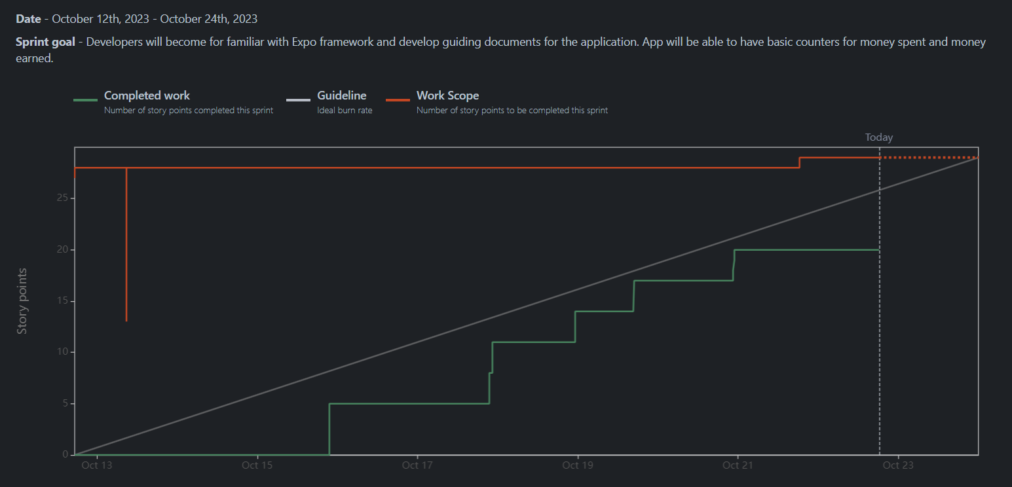

**Initial Scrum Board:**

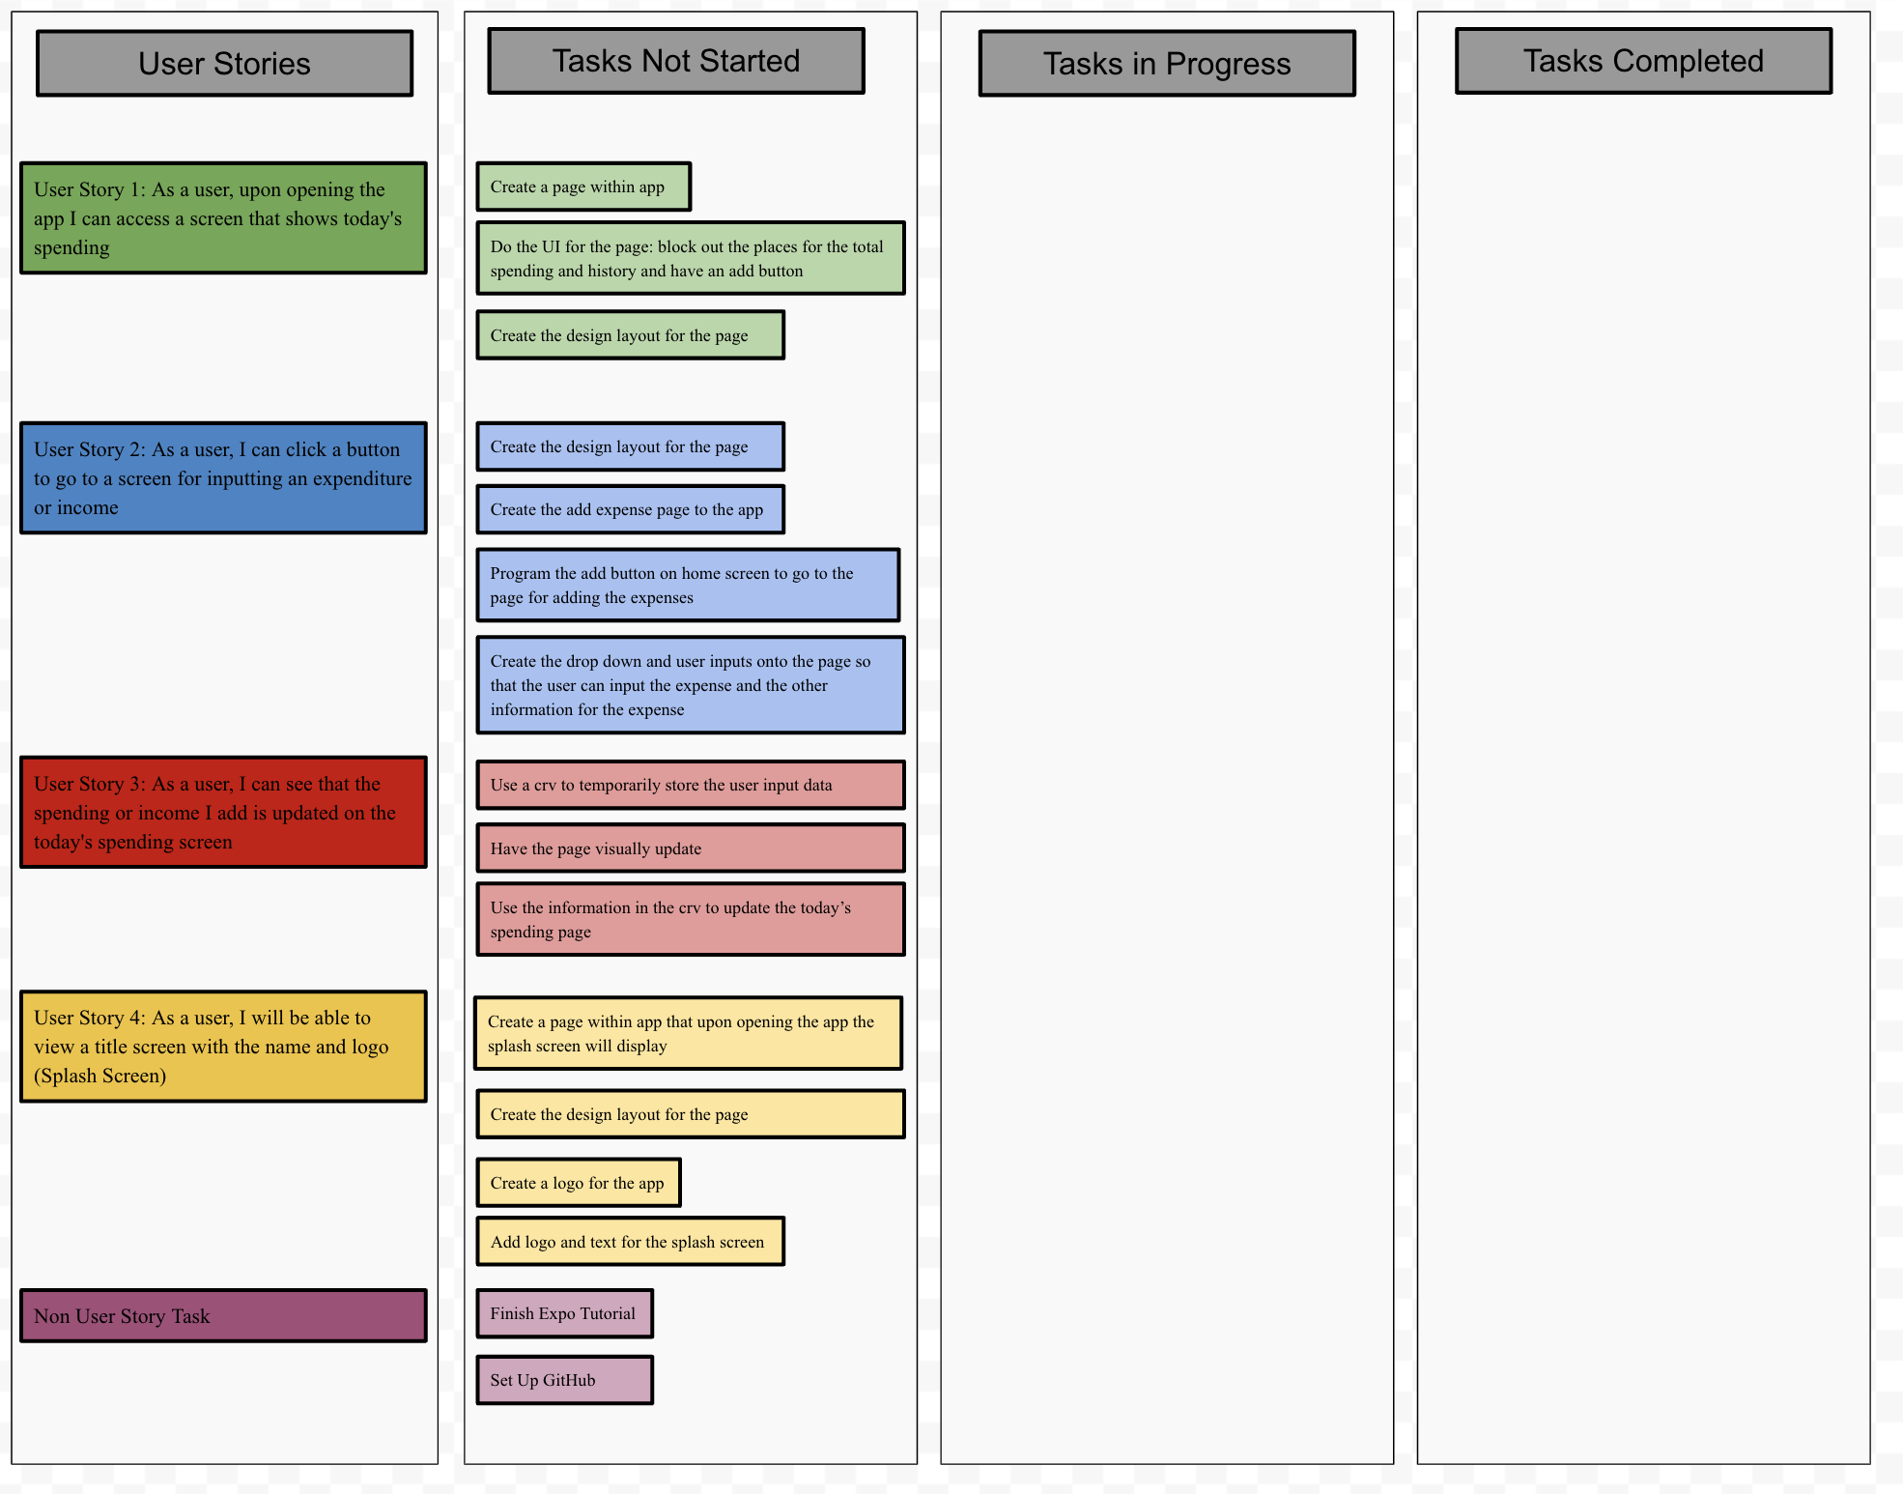

**Scrum Times:**

Mondays: 10am - 10:45 with TA

Thursdays: 4:15pm - 5:15pm

Sundays: 6pm - 7pm